Experiment No.09
Roll No. A055 | Name: Shantil Khadatkar
Program : BTech IT | Batch: A1
Subject: Drone Technology | Date of Experiment:
Date of Submission: | Grade:

A.1 Aim:
- To understand the process of calibrating Electronic Speed Controllers (ESCs) and the accelerometer sensor to ensure the proper functionality of a quadcopter.
A.2 Materials Required:
• Quadcopter frame with motors
• Electronic Speed Controllers (ESCs)
• Flight Controller (PX4)
• Transmitter and Receiver
• Battery
• USB Cable
• Ground Station Software (QGroundControl/Mission Planner)
• Propeller (should be removed during ESC calibration for safety)
A.4 Theory:
Part 1: ESC Calibration
Step 1: Remove Propellers
✓ For safety reasons, remove the propellers from all motors before proceeding with the ESC calibration.
Step 2: Connect the Flight Controller to Ground Station
✓ Power the flight controller by connecting it to the computer using a USB cable.
✓ Launch the ground station software (e.g., QGroundControl or Mission Planner).
Step 3: Enter ESC Calibration Mode
✓ Connect the battery to the quadcopter.
✓ Open the Power Setup menu in the ground station software.
✓ Choose the option to Calibrate ESCs. The system will guide you to enter calibration mode.
o In QGroundControl: Navigate to Vehicle Setup
> Power > ESC Calibration.
o In Mission Planner: Go to Initual Setup > Mandatory Hardware > ESC Calibration.
Step 4: Throttle Maximum Command
✓ Move the throttle stick of your transmitter to the maximum positoon.
✓ Plug in the battery. The ESCs will enter calibration mode, and you may hear beeps indicating readiness.
Step 5: Throttle Minimum Command
✓ After hearing the initial confirmation beeps, lower the throttle to the minimum position.
✓ The ESCs will then store the throttle range, and additional beeps will confirm successful calibration.
Step 6: Test the Calibration
✓ Disconnect the battery.
✓ Reconnect the battery and arm the quadcopter. Slowly increase the throttle to verify that all motors start spinning simultaneously.
Observations and Learning:
✓ Attached the images as an outcome of this practical.
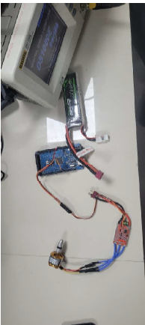

Observations and Learning:
Based on the steps and the experiment performed, here are our observations and details about the connections to the flight controller:
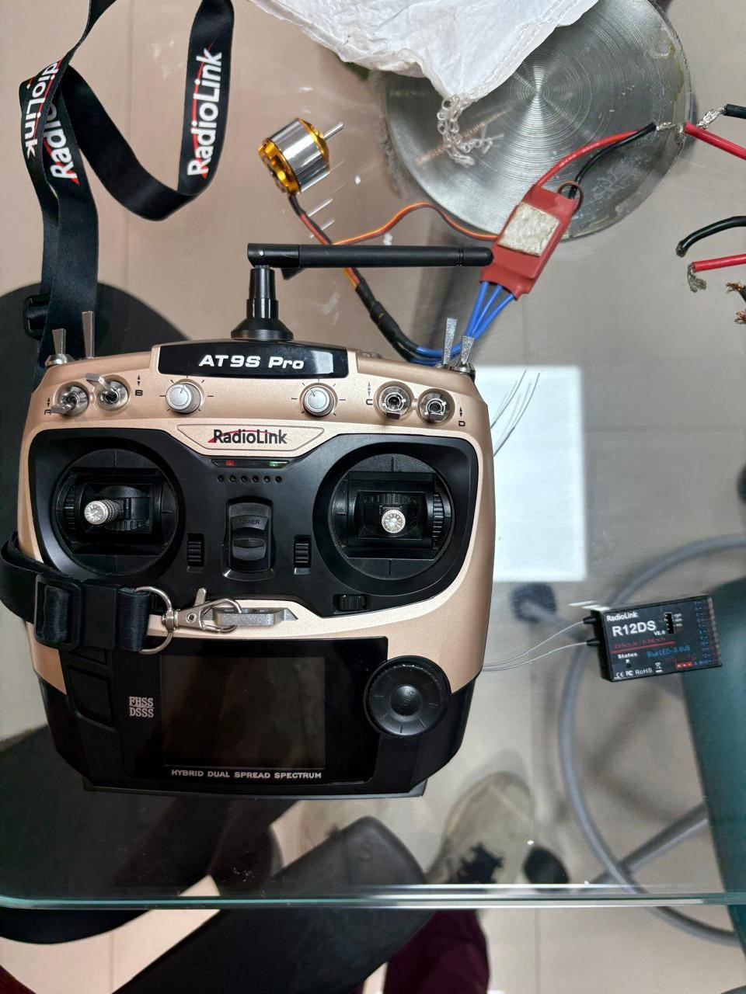

RadioLink
Transmitter

RadioLink
Receiver

Basic Connections
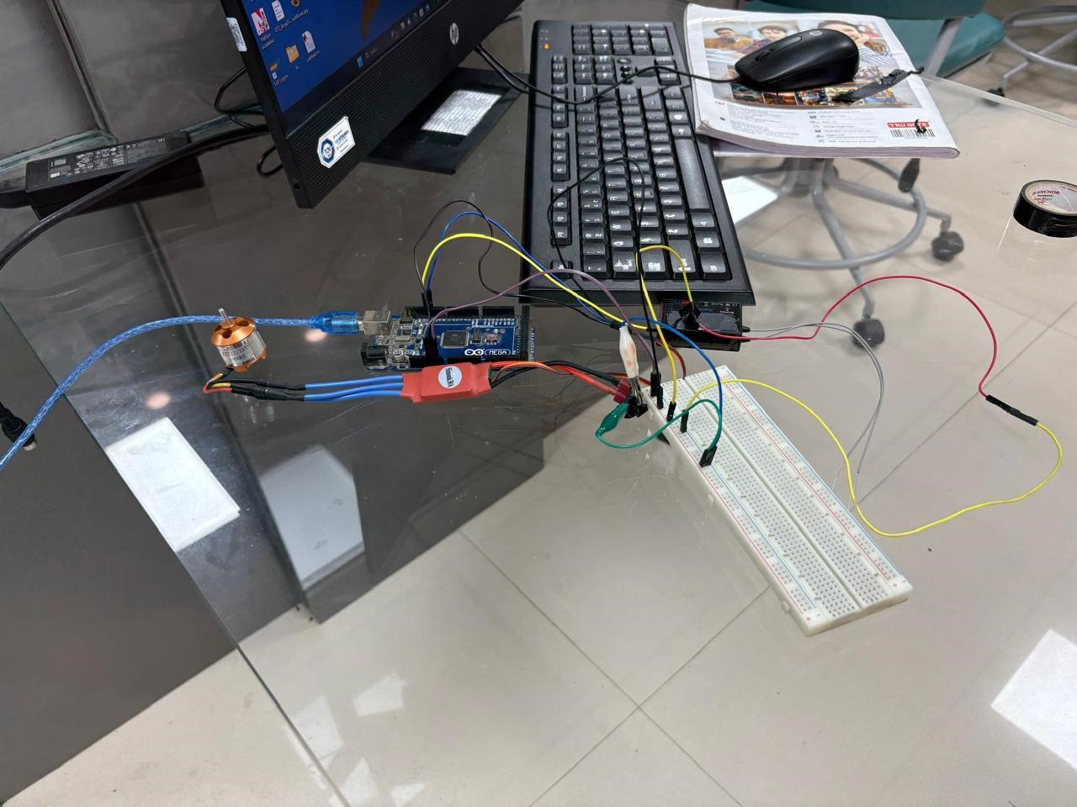

Breadboard

ESC

Arduino
(
Flight Controller
)

Motor

Connection to RadioLink
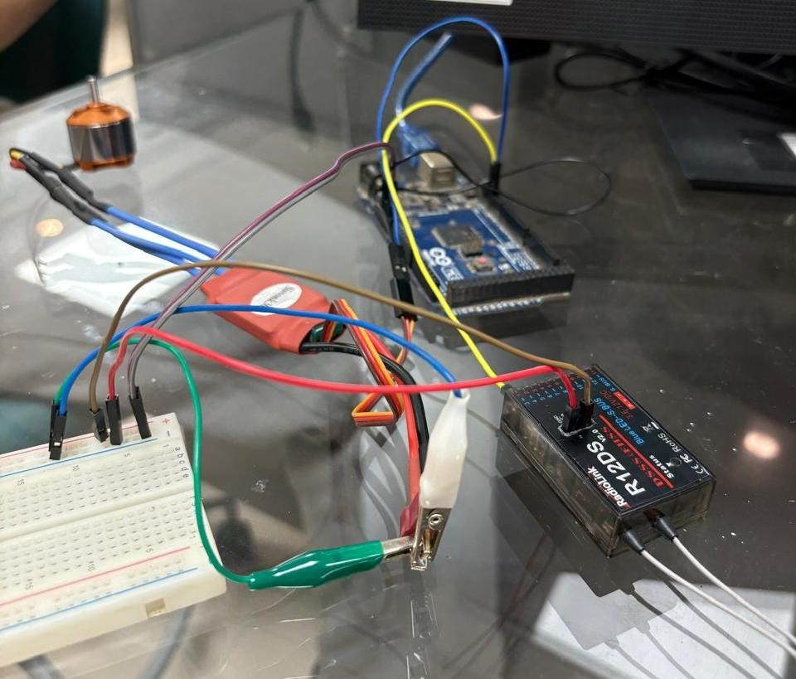

RadioLink

Crocodile Clip

We use a crocodile clip for more efficient power delivery.
(This setup can either be connected to the battery, or it can take power from the flight controller when connected to the PC: testing purposes only.)

Connection to the PC
When we connect this setup to the PC, due to some hardware troubles we couldn’t connect to the MissionPlanner. Although, the RadioLink did light up & the Radio Transmitter had it’s initial beeps, and this was observed in MissionPlanner:
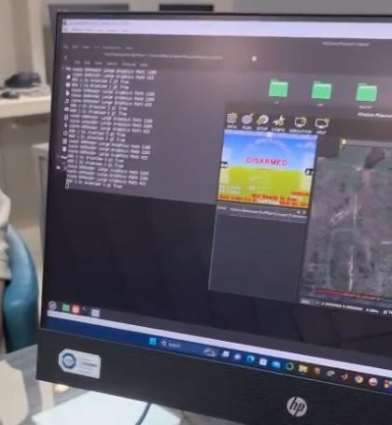
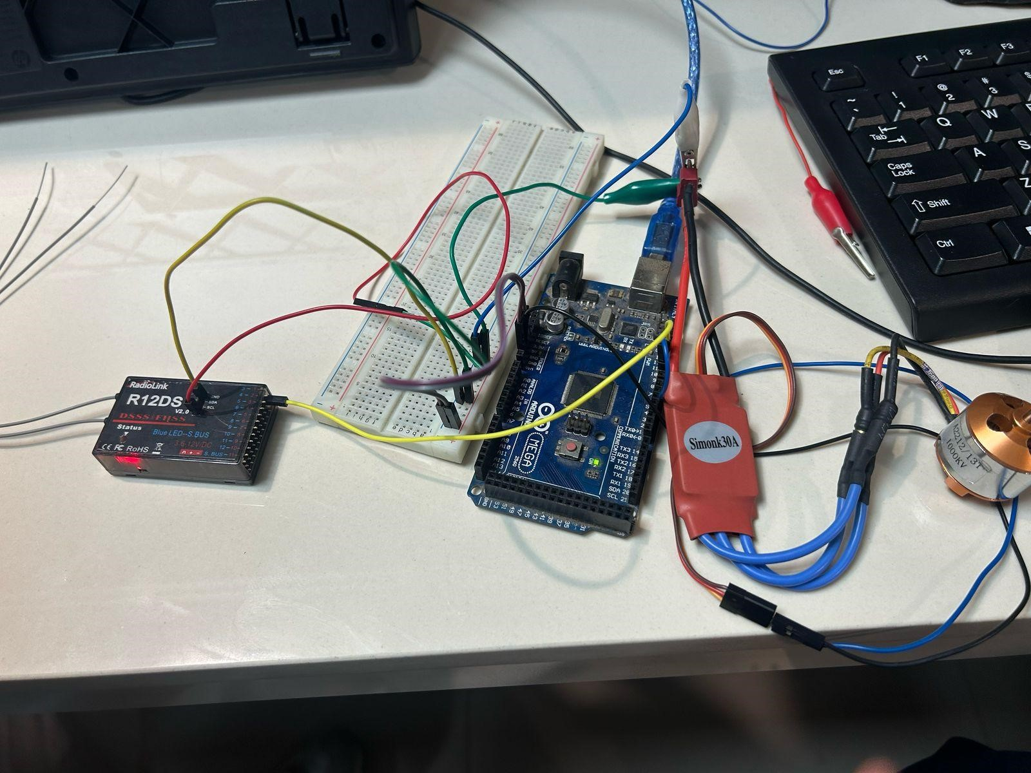

Connection to the PC

RadioLink

Flight Controller

ESC

Motor

Breadboard

Since the battery we had was LiPo and we did not want to risk tampering it, we connected the components to a Variable PSU, which is our main power source:
Power Source is providing 11.9 V (suitable according to our motor’s KV rating and ESC)
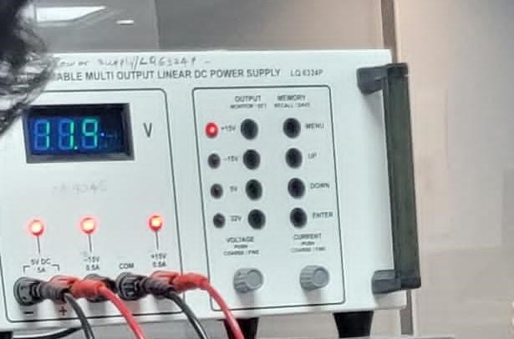

Switching to the Variable PSU
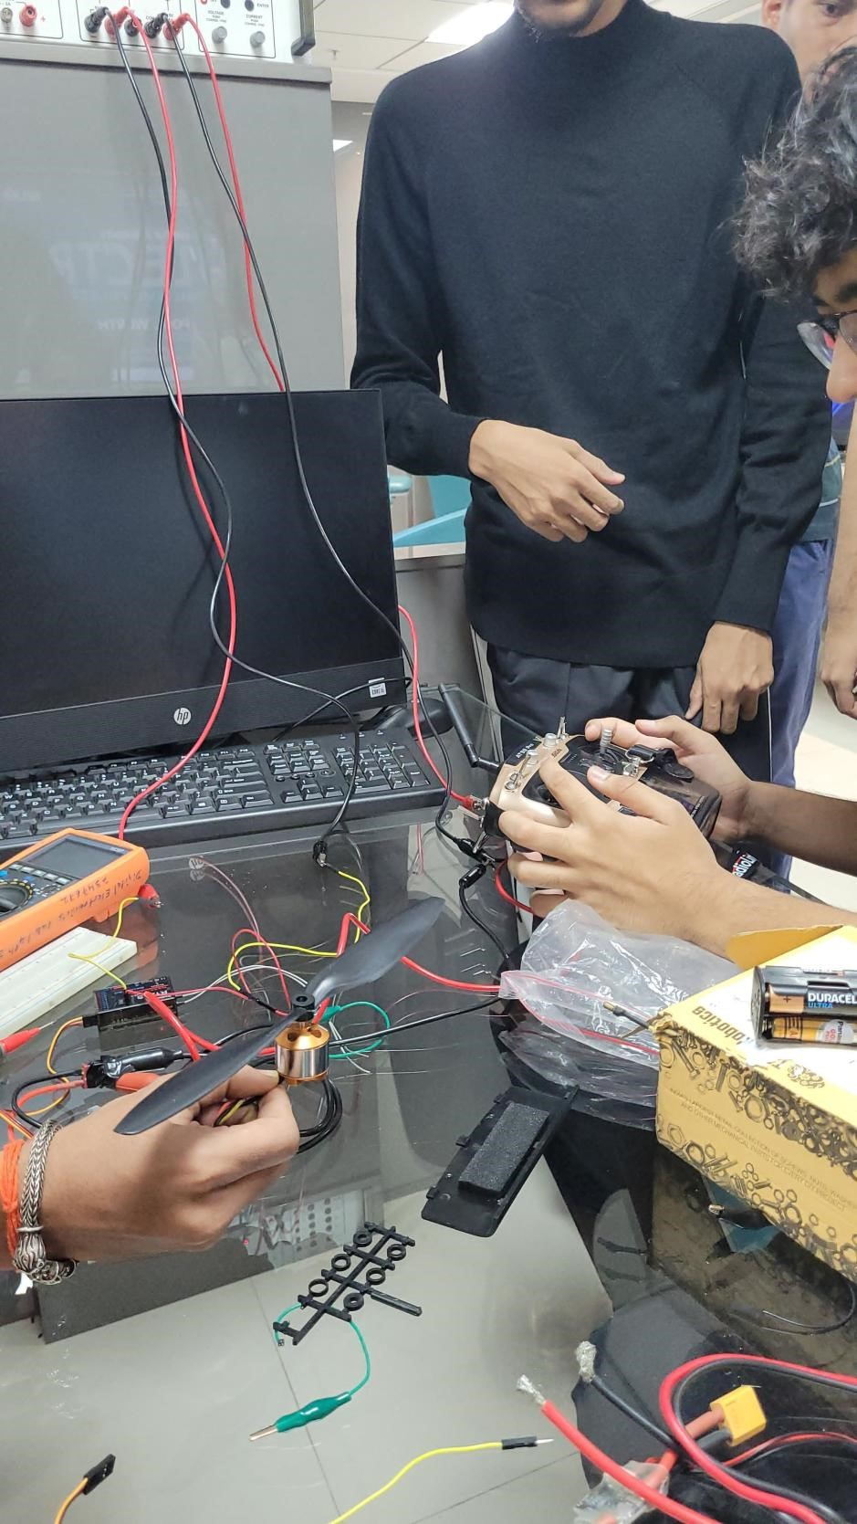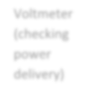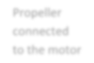

Variable PSU

Voltmeter
(
checking
power
delivery)

Propeller
connected
to the motor

Transmitter

Close Up of the Transmitter

Connection to the Transmitter (Remote Control)
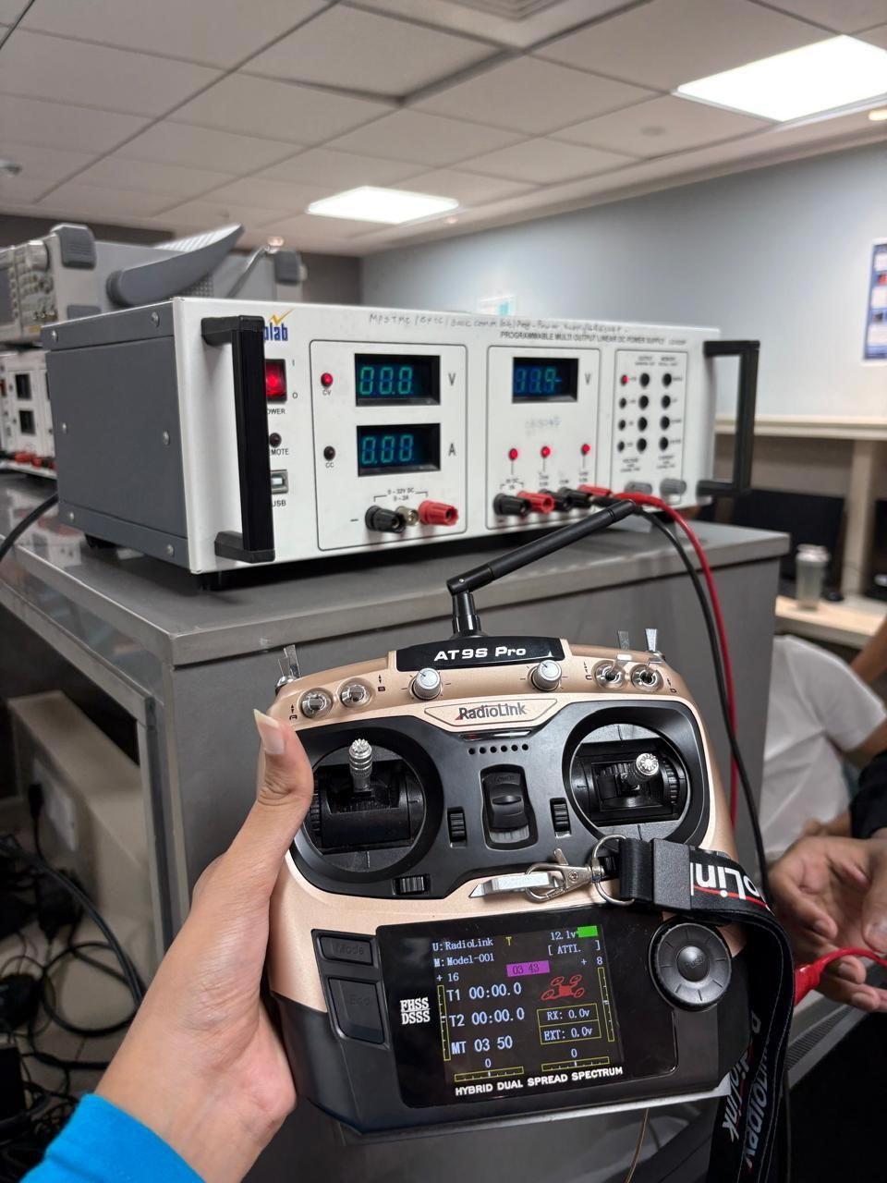

Not Connected yet:
N
etwork bars are not
visible

After establishing connection with the RadioLink (receiver), the screen looks something like this:

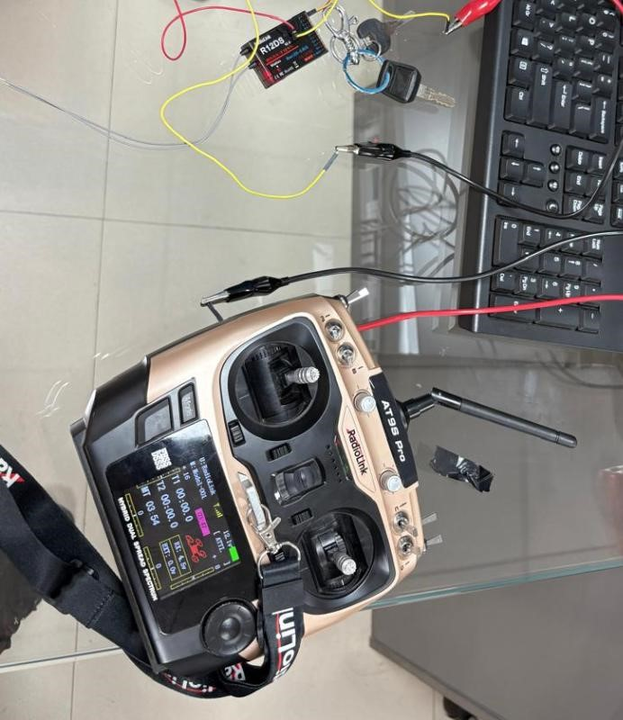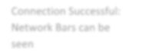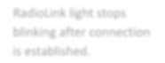

Connection Successful:
Network Bars can be
seen

RadioLink

light stops
blinking after connection
is established.

Using the Transmitter to Control Motor Rotation
Rotation of the Motor: (The propeller has been disconnected to avoid injuries.)
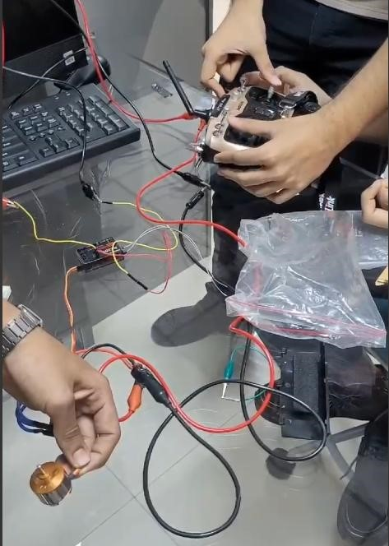

The motor can be seen rotating here.

Toggling Controls on the Transmitter:
MAX THROTTLE

The transmitter is sending a signal via RadioLink to perform the rotation based on the inputs, which goes further to the ESC that is connected to the motor; and the motor rotates according to the direction specified by the transmitter.

Reading of the Oscilloscope

The connections to the oscilloscope were done as follows:
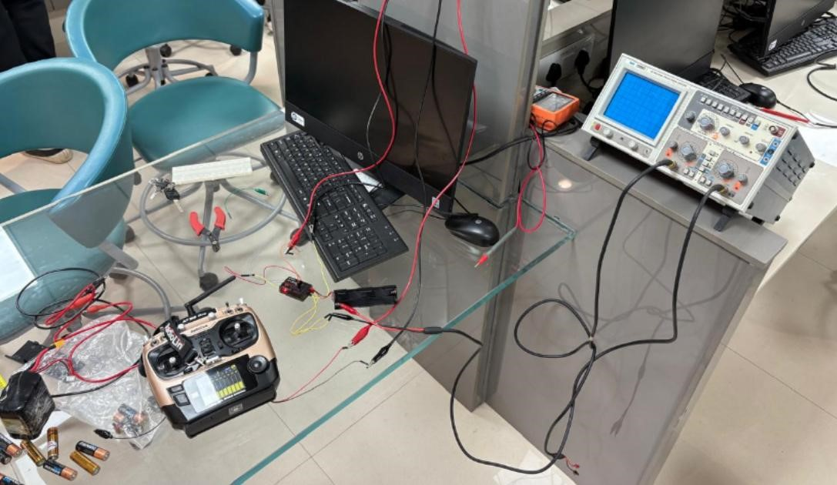
Readings Observed:
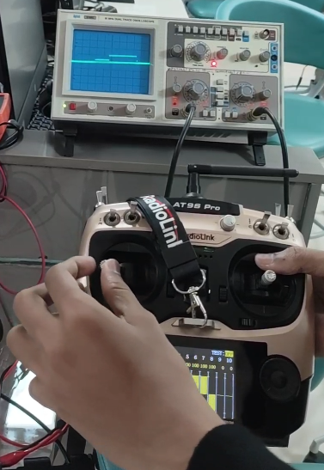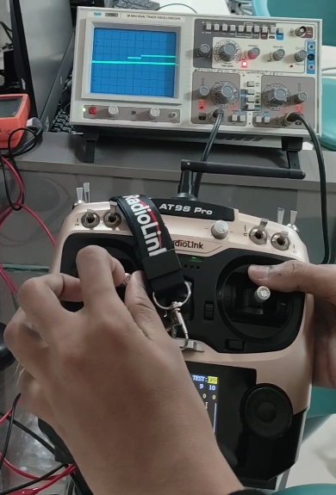
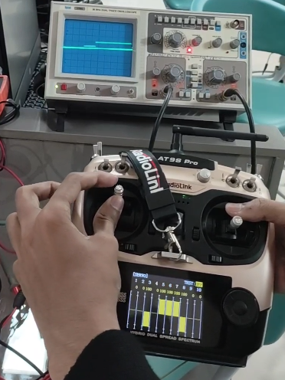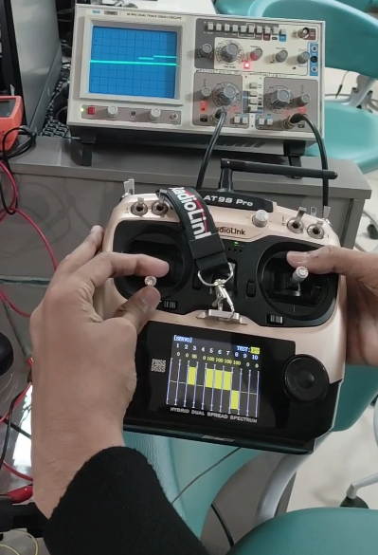
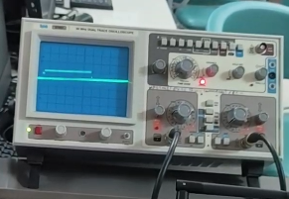
Stable Reading when no Input is pressed
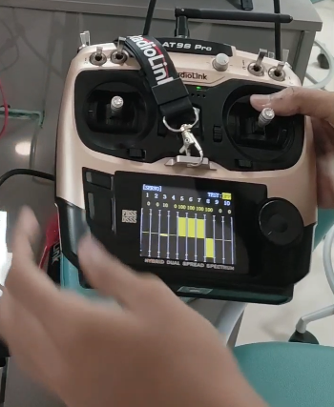 No Inputs Pressed
A slight disturbance in the wave is seen on the oscilloscope. Only Channel 3 and 4 were recorded

Conclusion:
We were able to establish connection between various components in a drone. Due to limitations in hardware and other software difficulties, the drone flight could not happen; but we managed to understand the mechanism behind the communication between the transmitter and the receiver and how the controls make the motors move via the ESC, and how the signals show up on the oscilloscope as readings.

